# *Secally Barbosa*

# *README file*

## About the Project/Project Title

The focal purpose of this project is to properly incorporate Python to make an application dashboard. This web application allows someone to view its data from the MongoDB. It is done by using Dash and a “middleware” interface in python. By using CRUD operations, data is processed between the MongoDB and the Python Dashboard.

## Motivation

*The project shows proof that data is easily accessible through Python and the dashboard.*

## Getting Started

## Getting the project to work involves setting the appropriate credentials in the init method of the class, as well as importing the database you wish to manipulate. Credentials are required since the database uses authentication. Then you need to place the "middle-ware" interface in the same directory as the Python dashboard. The dashboard is then set up using Python and the Dash framework. In the examples, animals from the Austin Animal Center (AAC) database are used.

Installation

Python is used as the programming language. Pymongo is used as a driver to correlation manipulations within the MongoDB and Python coding practices used throughout the project. MongoDB is a schema-less database that is easily used to handle the data provided for this project. Dash is the Python dashboard framework. Jupyter Notebook was used as the primary IDE to create codes/classes and allow us to test everything before finalizing.

Usage

With the completion of this project, the user can easily go through the database to which it is connected to. It is easy to sort, filter, and view all data.

Code Examples:

The code above was used to have the interface relate to the database we were looking for in the MongoDB. We connected to animals from the AAC.

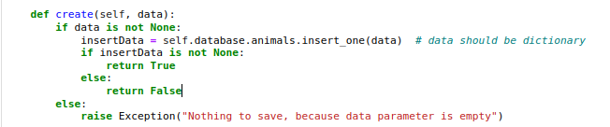

The code above is used to insert into the database that is connected. For this project, we made sure that the data is in the form of a directory for it to be inserted correctly.

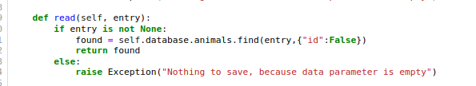

The code above is so someone can search for certain data or documents without the selected database. This is done by using a key value. Using this code will return a result in a list.

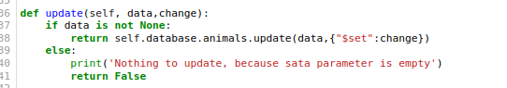

The code above is used to make edits/changes to an already existing entry within the selected database. It looks for a certain entry with the key value provided and allows the used to replace values desired. This would be used to make any modifications to entries within the database.

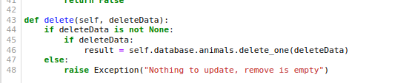

The code above is to remove or delete any existing entry that is within the database selected. Whichever entry matches the values entered will be removed/deleted.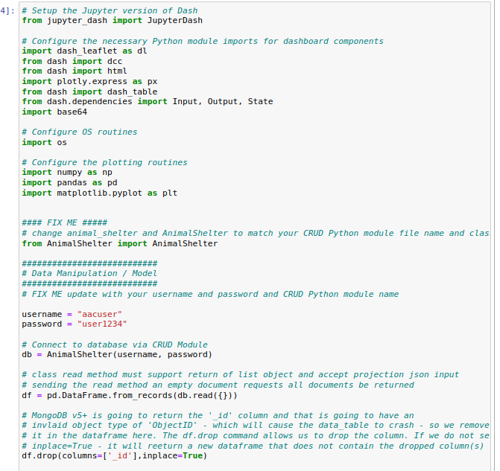

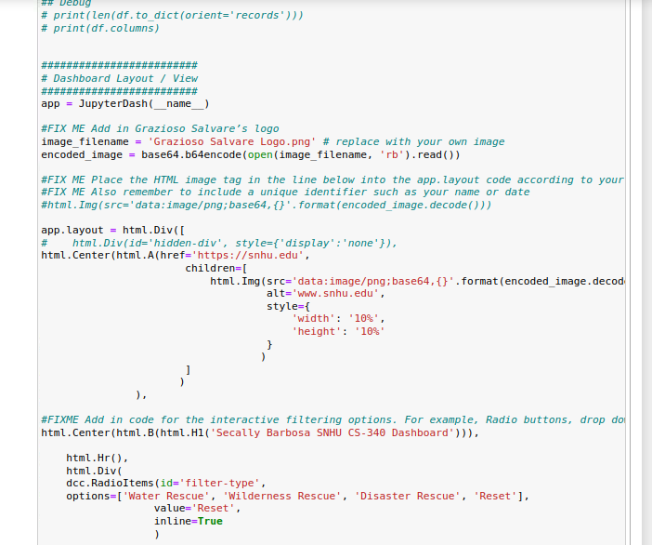

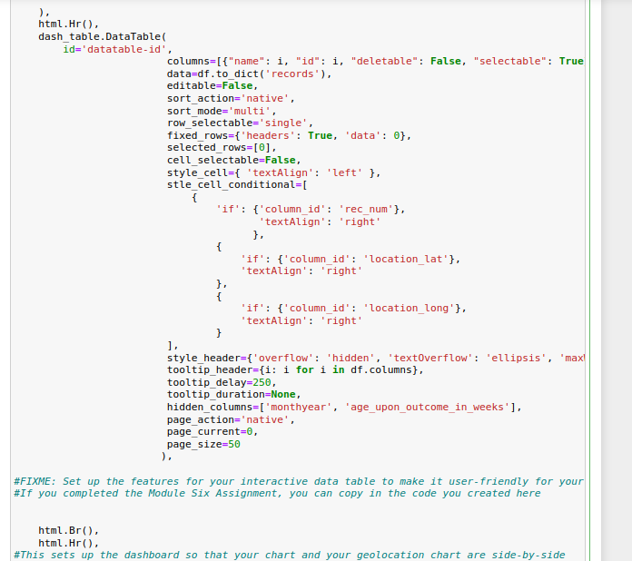

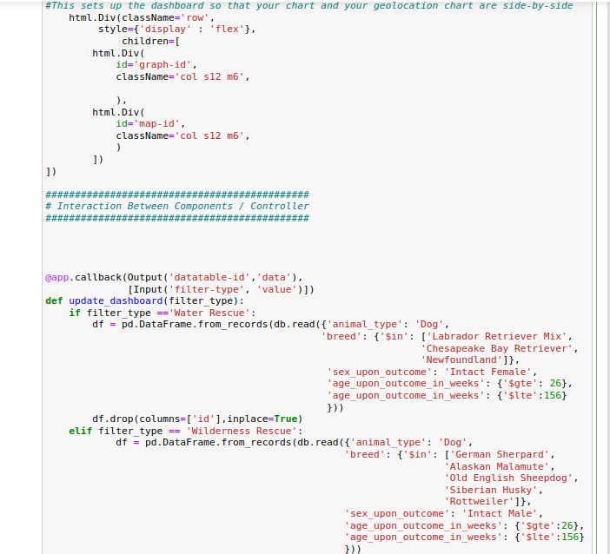

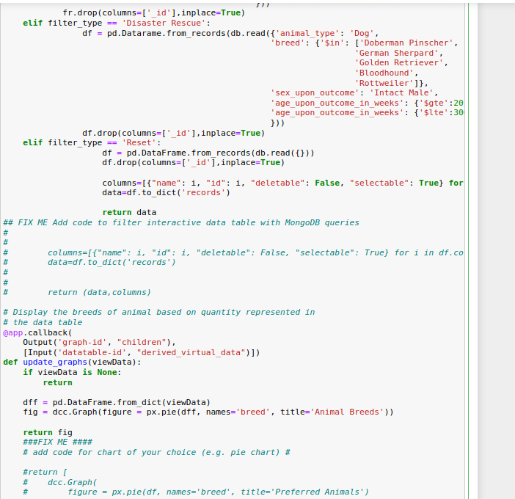

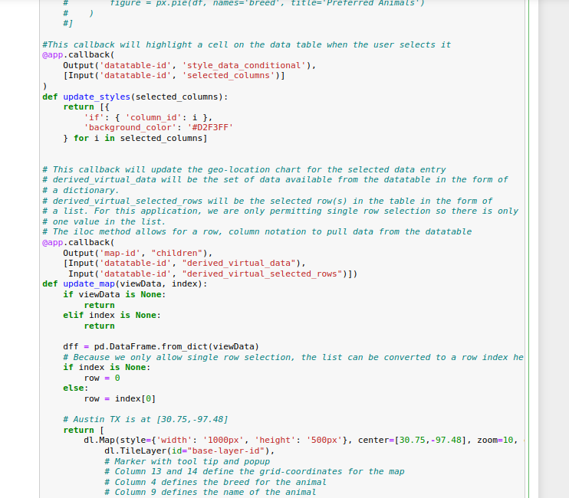

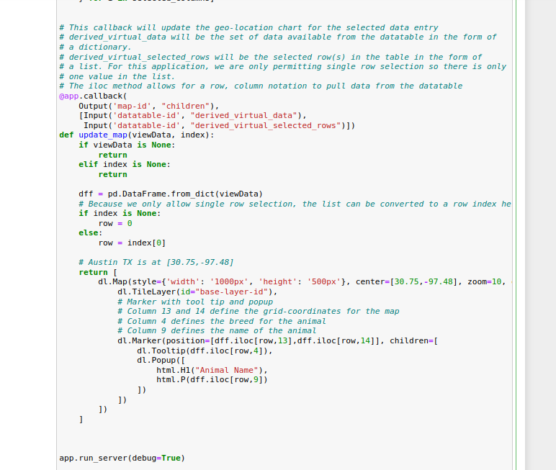

The codes provided above are all apart of the display process. A map was created within the web application code to display the geological element where the animals would be located. A graph was created as well as a chart.

Tests:

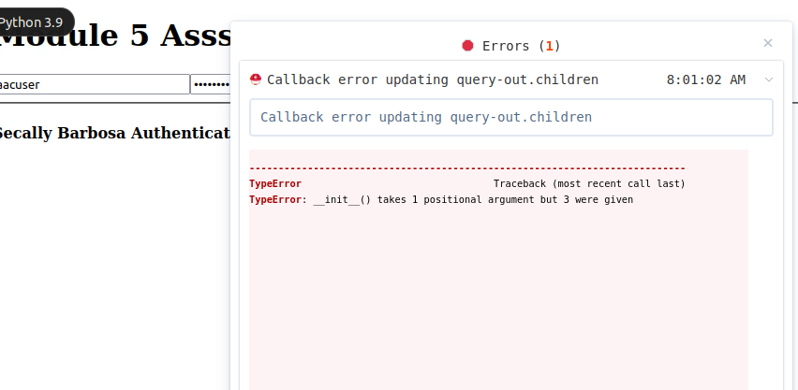

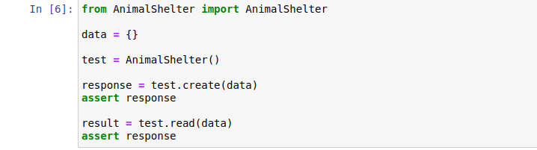

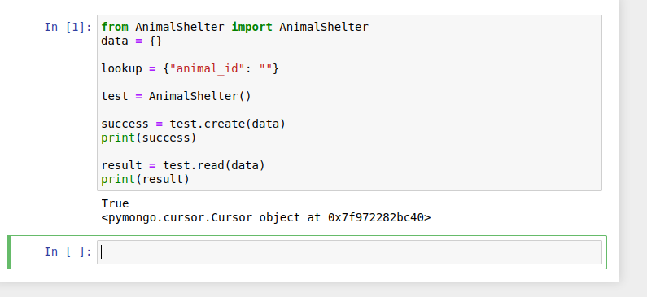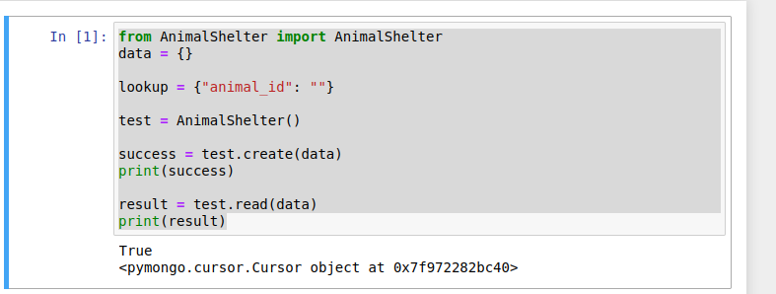

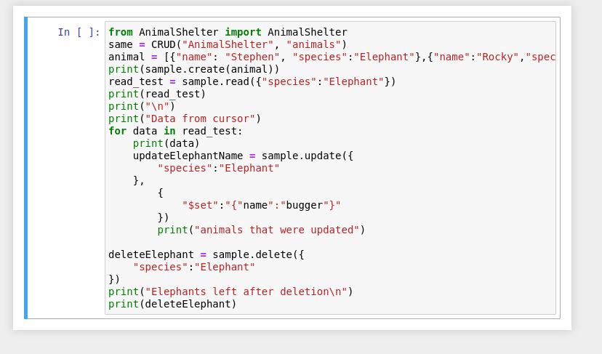

Tests throughout the project were completed to ensure things were working properly. Each method would be tested to ensure that important the project was successful.

Difficulties:

I struggled a lot with the second half of this project. I had a lot of syntax errors and even after fixing them, my codes were not working all together. I feel as if my coding practices are satisfactory, but in terms of using the same coding habits within all modules was making things very confusing. This resulted in me having issues viewing the output in DASH throughout all assignments. I spent time looking over issues, watched tons of YouTube videos, read the links included within the modules for help, but I feel as if I couldn’t get it perfect. I know I am on the right track, just some extra cleaning up. Overall, the project was great and with a few small practices are extra understanding, I am sure it would run perfectly.

## Contact

Secally Barbosa